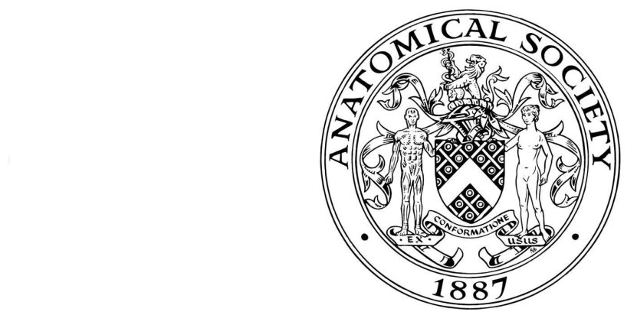
Bursary Application Form
Anatomical Society Training Programme
Sessions start 1 September 2023
The Anatomical Society is pleased to make financial bursaries available to Society members who have been accepted on to the Society’s Training Programme. The bursary is available for each year of the programme, and applications for it must be made separately each year. The bursary of £400 per module (up to £800 per year) is designed to be used for the module fee of £300 and to provide some funds for applicants to use in attending the residential course or other related expenses. Please note that the bursary applicant will be required to pay the module fee(s) (£300 per module) at the beginning of the year, and that the bursary will be paid out only after successful completion of the summer residential school.

Bursary applications will only be considered for applicants who are paid up members of the Anatomical Society, who have successfully registered for the Training Programme, and who have paid their registration fee.
All sections of the form must be completed.

1 APPLICANT’S DETAILS |  |  |  |  |  |  |  |  |  |  |  |  |  |  |  |  | Contact Address
 | Dr/Mr/Mrs/Miss/Ms etc.
 | Your preferred pronouns (he/she/they/other)
 | First names in full
 |  |  |  |  |  |  |  |  |  |  |  |  |  |  |  |  |  | Postcode
 | Preferred first name
 |  |  |  |  |  |  |  |  |  |  |  |  |  |  |  |  |  | Telephone number (including code) |  |  |  |  | Ext
 |  |  |  |  |  |  |  |  |  |  |  |  |  |  |  |  |  | Day
 | Surname/family name |  |  |  |  |  |  |  |  |  |  |  |  |  |  |  |  | Eve
 |  |  |  |  |  |  |  |  |  |  |  |  |  |  |  |  |  | Email address
 | Your date of birth (example 23 March 1995)
 | Day |  |  |  |  | Month |  |  |  |  | Year
 | Membership of the Anatomical Society since:

2 MODULES (SESSION 2023/24)

Please indicate which module(s) you will be undertaking

 | MODULE | Please tick module(s) in session 2023/24
1. | ATP 3 TRUNK  (RESIDENTIAL COURSE JULY 2024)
2. | ATP 4 NEUROANATOMY  (RESIDENTIAL COURSE JULY 2024)

3 BURSARY APPLIED FOR:

Please indicate which bursary you are applying for:

Bursary | Amount | Please tick which bursary you are applying for
One module | £400
Both modules | £800

Please fill out the table below with your bank details.

UK bank account | Name of account holder
 | Bank name
 | Sort code
 | Account number
Bank account outside UK | Name of account holder
 | Address of account holder (if different to above)
 | Name of bank
 | Address of bank
IBAN (International Bank Account Number)
BIC\SWIFT code

Applicant’s Signature |  | Date

4. DATA PROTECTION:-

I consent to the data included in this submission being collected processed and stored by the Anatomical Society | No |  | Yes |  | Please tick one box

Please return your completed (preferably typewritten) Bursary Form by E-MAIL to the Anatomical Training Programme Management Board c/o anatomytrainingprogramme@gmail.com
File: ATP-Bursary-Form-2023-FINAL-08062023

