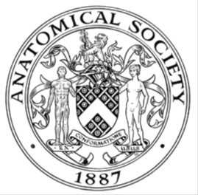
_______________________________________________________________________________________
AWARDEE REPORT FORM
_______________________________________________________________________________________

NAME |  | Sophie Gray
UNIVERSITY |  | University College London
NAME OF AWARD |  | Barclay-Smith Travelling Awards 2018/19
PURPOSE OF AWARD conference/event attended/organised (full name) with city and dates.
Awarded for The 19th Congress of the International Federation of Associations of Anatomists.
Excel London, 9-11th August 2019

REPORT: What were your anticipated benefits?
I was hoping that primarily my poster presentation would give me the chance to practice speaking to researches and academics about my research project.
I was excited to be able to attend specialist seminars from those who are currently at the top of their field.
COMMENTS: Describe your experience at the conference / lab visit / course / seminar/ event.
The event was very interesting. I had my poster presentation on the first day of the conference. This was a really enjoyable experience, as I was able to explain and discuss my work with both students like myself and delegates of the conference.
I found the plenary lectures extremely interesting. I thought in particular the talks on the history of Gray’s Anatomy, art and anatomy, and transgender surgery were extremely interesting and engaging to such a diverse audience.
The seminars were varied. I really enjoyed the seminars on ‘The anatomy of our anatomy: how humans and their relatives came to be’ and ‘The developmental anatomy of craniofacial and neural tube birth defects and prospects for their repair and prevention’. In the latter session the presentation by Professor Andrew Copp, who I have previously seen present at UCL, very efficiently geared this talk to a specialist level, whilst still making it accessible.
There were seminars where I feel the quality of presentation did not do justice to the work of a given researcher, and it meant that audience members left during talks/ presentations and this was disruptive.

REPORT: In relation to skills, what were the most important things you gained? (does not apply to equipment grant. For public engagement/outreach awards what did your audience gain and how did you evaluate success?
I gained skills to present my research in public to a range of attendees, from those with a background in the field to those from entirely different anatomical research fields.

REPORT: How do you think you will put this learning experience into practice in the future? For public engagement/outreach awards how with the materials/knowledge generated by this activity be used in the future?
This learning experience will help me to be more confident in presenting my research in the future and more likely to apply to present my research in poster form.

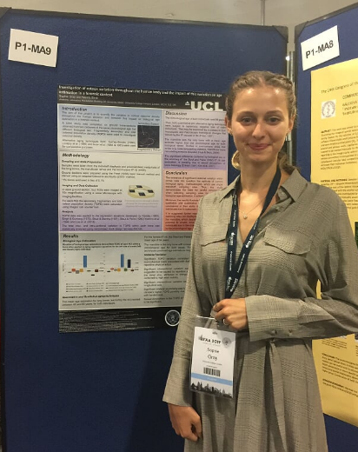
Data Protection/GDPR: I consent to the data included in this submission being collected, processed and stored by the Anatomical Society.
YES
Graphical Images: If you include graphical images you must obtain consent from people appearing in any photos and confirm that you have consent. A consent statement from you must accompany each report if relevant. A short narrative should accompany the image.
YES

Copyright: If you submit images you must either own the copyright to the image or have gained the explicit permission of the copyright holder for the image to be submitted as part of the report for upload to the Society’s website, Newsletter, social media and so forth. A copyright statement must accompany each report if relevant.
YES

SIGNATURE | SOPHIE GRAY |  | DATE | 17/08/2019
If submitted electronically, a type-written name is acceptable in place of a hand-written signature

File: AS-Award-Report-Form-BLANKCO-SEAL-date110216-Amended AT-070818

