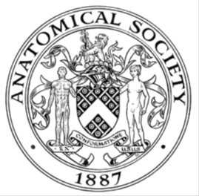
_______________________________________________________________________________________
AWARDEE REPORT FORM
_______________________________________________________________________________________

NAME |  | Dr Zubeyde Bayram-Weston
UNIVERSITY |  | Swansea University
NAME OF AWARD |  | Application for Public engagement and Outreach Grant
PURPOSE OF AWARD conference/event attended/organised (full name) with city and dates.
To purchase materials to create and develop “Snap Anatomy” activity for various public engagement and outreach events as follows:
Year 9 conference, 18 December 2018, Singleton Campus, Swansea University Sa2 8PP, Swansea.
Cardiff Science Festival, Museum After Dark – Leonardo da Vinci, 28th February 2019, National Museum Cardiff, CF10 3NP
Soapbox Science Swansea, Oxford Street Swansea, 22nd June 2019,Swansea SA1 3AE.
Cardiff Summer Science Festival 16th August 2019, Capitol Shopping Centre, CF10 2 HQ .
Cardiff Summer Science Festival 23rd August 2019, Capitol Shopping Centre, CF10 2 HQ.
REPORT: What were your anticipated benefits?
In presenting these events, my anticipated benefits were

1- To increase knowledge and understanding of anatomical terminology (combining with function) and for the target audience to understand anatomical concepts.
2- To convey specific diseases and health issues especially different cell types and how they work, why anatomy matters in disease.
3- Increase awareness of current research, especially, my own research project on Neuroanatomy and Neurodegenerative disorders.
4- Provide a platform for additional skills by participation through team work and effective communication in Anatomical terminology.

COMMENTS: Describe your experience at the conference / lab visit / course / seminar/ event.
At the Museum after dark event (The Flagship event for Cardiff Science Festival 2019), our activity was located in The Insight gallery at the National Museum Cardiff alongside various other displays, activities, shows and presentations. The event had over 1000 attendees in all with a variety of ages and genders including families participating together.

The game is called “Snap Anatomy”, and based on the common card game of snap. It has large cards with 8 anatomical images on each card. There is only one matching image on each card. The first player to spot the matching card shouts it out and wins the cards. Participants were engaged with this anatomical activity and seemed to enjoy being part of the game. The images sparked curiosity among participants who were keen to learn more about unfamiliar images and body parts.

For the year 9 Conference we had a creativity corner where participants made paper hats which included brain anatomy. They were able to learn parts of the brain whilst assembling the hats and also take them home to improve their knowledge further. In addition They were also able to make their own neurons from different materials including drawing, Paper, Play dough and pipe cleaners.

I was selected to present at Soapbox Science Swansea (a national public engagement initiative) along with eleven other female scientists from across Wales. Standing on a soapbox in Swansea town centre, I pitched Anatomy as my subject. To draw people in, I utilised several props, a brain model, Paper brain hats and “Snap Anatomy” activity. This was a fantastic event to be part of as the audience were not planning on attending an event that focused on science, many people just saw that something was going on so came over to listen to what we were saying. The twitter feed exemplified just some of the enthusiastic responses.

Due to the fact that Snap Anatomy was a very popular event at The Cardiff Winter Science Festival, we have been asked to deliver this activity again. Plans are already in place to present Snap Anatomy on 16th August and 23rd of August 2019 at the Capitol Shopping Centre, Cardiff.

REPORT: In relation to skills, what were the most important things you gained? (does not apply to equipment grant. For public engagement/outreach awards what did your audience gain and how did you evaluate success?
During the activity, it was very clear that participants had enjoyed learning about anatomy and how it works and answered questions we asked. I am an enthusiastic anatomist and it was a great pleasure for me to disseminate my knowledge and passion to the public. It is important to me to communicate with people to create a spark to generate an interest in anatomy. It was evident that participants learned new anatomical structures and had an opportunity to discuss this with experts.

Participants were asked to evaluate the activity by putting a counter into one of three boxes (Excellent, good and room for improvement) and all participants voted for Excellent and verbally confirmed that it was a very good educational game. We also provided a questionnaire to evaluate the activity and modify it if necessary. The outcomes of the activity were positive, and participants described it as “interesting”, “amazing”, “good” and “fun”. There were no suggestions for improvement.
We also asked participants to draw or write one thing they had learned to create visual evidence for analysing the activity’s effectiveness in communicating the core messages ( Figure1).
After the event, We were informed by organizers that The “Snap Anatomy” activity was very popular and appealed to diverse age groups and audiences especially with families. A number of younger participants said they were keen to become future scientists.

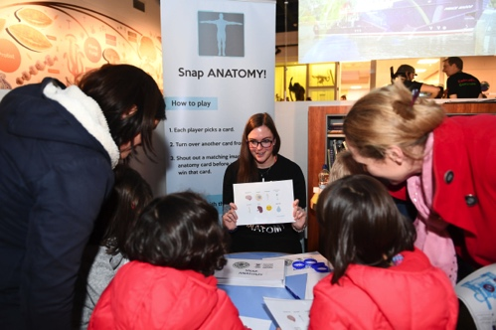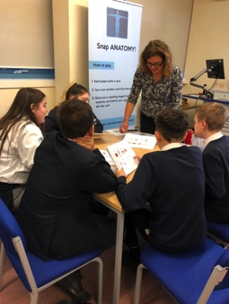
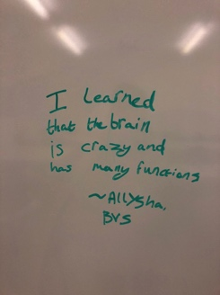
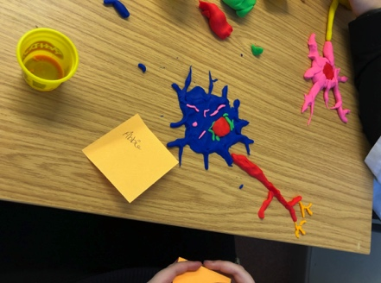

Figure 1: a ) Image of visitors are playing Snap Anatomy card game at Cardiff Museum, b) Image of Y9 students playing Snap Anatomy card game at Swansea university, c) Images from students feedback on the whiteboard d) a neuron made from a play dough at Year 9 Conference Swansea event.

REPORT: How do you think you will put this learning experience into practice in the future? For public engagement/outreach awards how with the materials/knowledge generated by this activity be used in the future?
This award has allowed me to purchase materials to create and develop new activities to be able use at various public engagement and outreach events in Swansea and Cardiff. In addition to these events, we will continue to use the activity that we have developed at future public engagement events such as The Swansea Science Festival in October 2019 which is predicted to attract more than 6000 attendees.

In addition, the cards can be electronically obtained and printed from the Anatomical society to allow easy access for schools, teachers and children to develop their anatomy knowledge further. We hope this will spark further interest in Anatomical science subjects. The feedback received will be continuously reviewed to integrate suggestions and adapt or improve the activities at future events.
Data Protection/GDPR: I consent to the data included in this submission being collected, processed and stored by the Anatomical Society.
YES
Graphical Images: If you include graphical images you must obtain consent from people appearing in any photos and confirm that you have consent. A consent statement from you must accompany each report if relevant. A short narrative should accompany the image.
YES
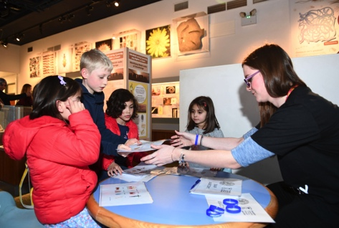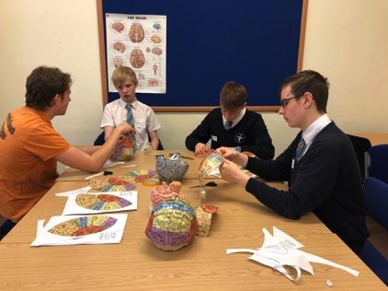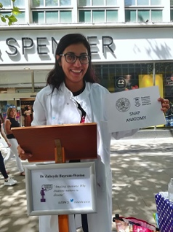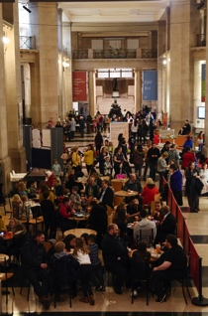

Figure2 : a) participants engagement with Snap Anatomy at Cardiff Science festival b) Y9 students are assembling paper brain hats and learning brain structures c) I gave an talk about Anatomy to public at Soapbox Science Swansea using Anatomy snap game is one of the activities, d) an image of After Dark Event in Cardiff Museum.

Copyright: If you submit images you must either own the copyright to the image or have gained the explicit permission of the copyright holder for the image to be submitted as part of the report for upload to the Society’s website, Newsletter, social media and so forth. A copyright statement must accompany each report if relevant.
We own the copyright for these images and we consent to its use.

SIGNATURE | Zubeyde Bayram-Weston |  | DATE | 28.06.2019
If submitted electronically, a type-written name is acceptable in place of a hand-written signature

File: AS-Award-Report-Form-BLANKCO-SEAL-date110216-Amended AT-070818

