_______________________________________________________________________________________
AWARDEE REPORT FORM
_______________________________________________________________________________________

NAME |  | Fiona Cronin
TWITTER HANDLE* optional |  | @FionaCronin2
UNIVERSITY |  | University of Limerick
NAME OF AWARD |  | Barclay-Smith travel award
PURPOSE OF AWARD conference/event attended/organised (full name) with city and dates.
Attendance at Anatomical Society Summer Meeting at Bangor, 25-27th July 2023

REPORT: What were your anticipated benefits?
I attended the conference to share the results of a recent study as a poster presentation. I hoped to get some feedback on my presentation from fellow conference attendees and implement this when doing further analysis.
I also looked forward to being exposed to research being carried out by the attendees and potentially making connections with fellow anatomists, particularly early career members of the society.
COMMENTS: Describe your experience at the conference / lab visit / course / seminar/ event.
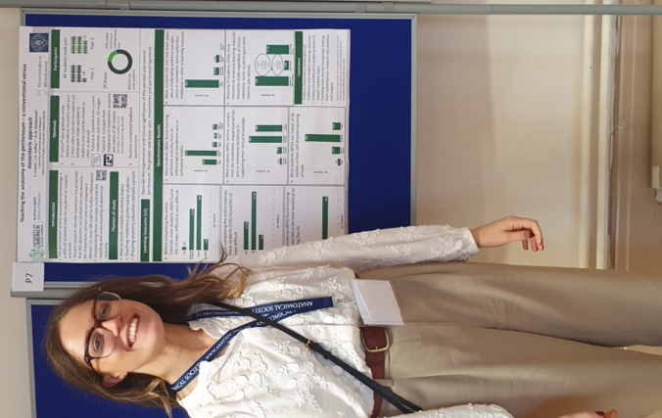
The conference provided a unique opportunity to engage with researchers from various disciplines in anatomy and at various stages of their careers, all in a friendly atmosphere. I was grateful for the opportunity to speak with other early career anatomists, particularly during the poster sessions and social events.
The presentations and discussions generated during the sessions were enlightening. I particularly enjoyed the keynote talk given by Rui Diogo on the links between anatomical development and evolution. The education session was of particular interest to me for my current research project and discussions on the use of AI in anatomy education left me with much to think about during my journey back home.

REPORT: In relation to skills, what were the most important things you gained? (does not apply to equipment grant. For public engagement/outreach awards what did your audience gain and how did you evaluate success?
I got the opportunity to exercise my presentation skills during the poster session and listening to the various talks given by others revealed different techniques I could use to engage the audience and communicate effectively when I have the opportunity to present in the future.

REPORT: How do you think you will put this learning experience into practice in the future? For public engagement/outreach awards how with the materials/knowledge generated by this activity be used in the future?
I received some valuable feedback during the poster session which I will certainly consider when writing up this research for my thesis.
I also hope to put the communication skills I gained and witnessed into action during my teaching practice and presentations.
Data Protection/GDPR: I consent to the data included in this submission being collected, processed and stored by the Anatomical Society. Answer YES or NO in the Box below
YES
Graphical Images: If you include graphical images you must obtain consent from people appearing in any photos and confirm that you have consent. A consent statement from you must accompany each report if relevant. A short narrative should accompany the image. Answer N/A not applicable, YES or NO in the box below
YES
Copyright: If you submit images you must either own the copyright to the image or have gained the explicit permission of the copyright holder for the image to be submitted as part of the report for upload to the Society’s website, Newsletter, social media and so forth. A copyright statement must accompany each report if relevant. Answer N/A not applicable, YES or NO in the box below
YES – image is my own

SIGNATURE | Fiona Cronin |  | DATE | 11/08/23
If submitted electronically, a type-written name is acceptable in place of a hand-written signature

File: AS-Award-Report-Form-220922 – International Conference

