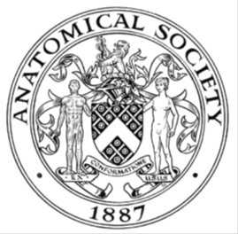
_______________________________________________________________________________________
AWARDEE REPORT FORM
_______________________________________________________________________________________

NAME |  | Hazel Allardyce
UNIVERSITY |  | University of Glasgow
NAME OF AWARD |  | Barclay Smith Travelling Award Round 5 2018/19
PURPOSE OF AWARD conference/event attended/organised (full name) with city and dates.
To attend the IFAA Congress 2019 hosted by the Anatomical Society at the ExCel Centre London from the 9th to 11th of August 2019 and present my undergraduate work at an organised symposium.

REPORT: What were your anticipated benefits?
By attending this congress, I hoped to meet anatomists from different fields to widen my understanding of current research and network with others that I may be able to collaborate with in future.

By presenting the research that I have conducted, I hoped to improve my presentation skills and increase my confidence while describing my work to academics.
COMMENTS: Describe your experience at the conference / lab visit / course / seminar/ event.
The IFAA Congress, London 2019, was the first international conference that I have attended. It provided me with a wonderful opportunity to meet with academics and researchers from around the globe, hear seminars from some very prestigious individuals in the field, including Susan Standring, and present my own research.

I attended a wide array of seminars and symposia that detailed many different aspects of anatomical research, from evolution to education, to art in anatomy. I gained a fantastic understanding of the many routes that are available in the field of anatomy and areas that I may possibly enter during my career. I attended the student evening which allowed me to meet fellow anatomists at similar stages in their career and form a peer group for support and advice in our studies and career paths. I spent time at poster sessions speaking with researchers and gaining insight into their work, as well as tips to help me with poster design. During tea breaks I was able to network with many other anatomists and clinicians as well as chat with people I had met at previous meetings of the Anatomical Society.

On the last day of the conference I was the final speaker in the “Insights into therapeutic success and challenges in motor neurone diseases” along with colleagues from The University of Edinburgh and The University of Aberdeen. During these two hours we provided the audience with a brief understanding of the ongoing research into rare forms of motor neurone disease, including spinal muscular atrophy (SMA). I presented the research conducted during my placement year at The University of Aberdeen on the importance of understanding non-neuromuscular pathologies in the development of therapies for SMA. As a junior anatomist that has just graduated from my undergraduate degree, this was a fantastic opportunity and wonderful experience to be able to present my own research, which I will be continuing during my PhD. Our symposium was well received with probing questions asked. I have included a photo of our symposium speakers as well as one of my presentation.

Over the three days of the IFAA Congress I attended as many sessions as I could to immerse myself in the meeting. It was a very enjoyable experience and I believe it will assist me immensely with future endeavours. I wish to thank the anatomical society for their funding.

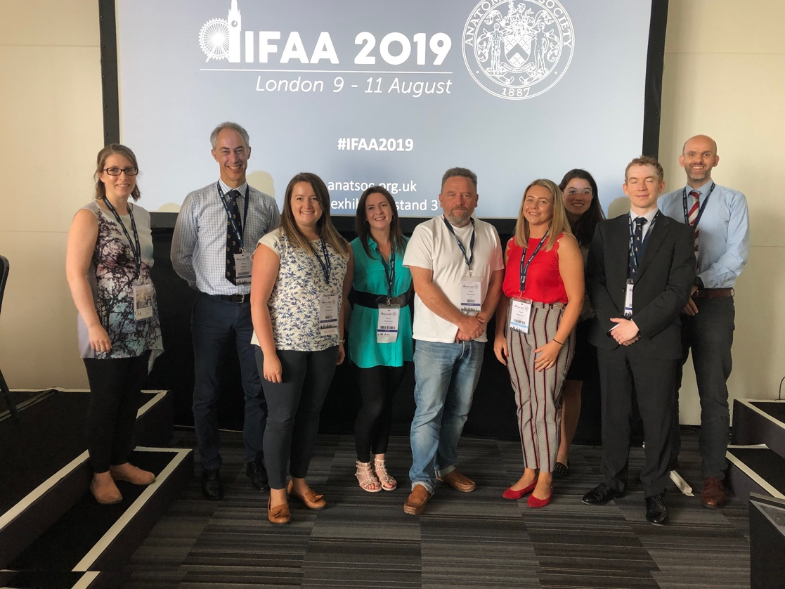
Speakers at the Insights into therapeutic success and challenges in motor neurone disease symposium. From left to right: Dr Lyndsay Murray, Professor Simon Parson, Dr Helena Chaytow, Dr Alison Thomson, Audience guest Professor Peter Dockery, Hazel Allardyce, Rachel Kline, Dr Ross Jones, Professor Thomas Gillingwater.
Consent was obtained from all individuals.

REPORT: In relation to skills, what were the most important things you gained? (does not apply to equipment grant. For public engagement/outreach awards what did your audience gain and how did you evaluate success?
The most important things I gained were a new confidence in both my own work and in meeting new people, especially experienced individuals in anatomy. I believe that this opportunity has not only helped to improve my presentation skills but also to gain skills in writing a presentation for an audience who do not work in the same areas of research and allowing them to grasp the main concepts of why the work is important and the difference it will make.
REPORT: How do you think you will put this learning experience into practice in the future? For public engagement/outreach awards how with the materials/knowledge generated by this activity be used in the future?
I believe this learning experience will assist me in the future both during my PhD and in future career paths. By allowing me to present my work at this international conference I was able to practice and further develop essential skills. In future presentations I believe that I will be more confident as this experience has shown me the support of the anatomical community. I hope to be involved in anatomical teaching in the future and feel that by presenting to groups of people such as during this congress, I will feel more comfortable with others, including students.
Data Protection/GDPR: I consent to the data included in this submission being collected, processed and stored by the Anatomical Society.
YES
Graphical Images: If you include graphical images you must obtain consent from people appearing in any photos and confirm that you have consent. A consent statement from you must accompany each report if relevant. A short narrative should accompany the image.
YES

Copyright: If you submit images you must either own the copyright to the image or have gained the explicit permission of the copyright holder for the image to be submitted as part of the report for upload to the Society’s website, Newsletter, social media and so forth. A copyright statement must accompany each report if relevant.
YES

SIGNATURE | Hazel Allardyce |  | DATE | 18.09.19
If submitted electronically, a type-written name is acceptable in place of a hand-written signature
File: AS-Award-Report-Form-BLANKCO-SEAL-date110216-Amended AT-070818

