Biology and therapeutic potential of enteric nervous system stem cells for spinal cord repair

Supervisors: Dr Alan Burns http://www.ucl.ac.uk/slms/people/show.php?UPI=AJBUR26
Dr Nikhil Thapar http://www.ucl.ac.uk/slms/people/show.php?UPI=NTHAP68

Address: Neural Development Unit, UCL Institute of Child Health, London

Traumatic spinal cord injury affects approximately 40,000 individuals in the UK at any one time. Most sufferers have devastating paralysis, multisystem impairment and reduced life expectancy, yet despite extensive research there remains no cure. The most promising therapeutic potential comes from the use of stem cells to replace damaged neurons, promote axonal regeneration and limit scar formation. There remain, however, significant limitations to the sourcing of suitable stem cells. This study will explore the use of stem cells obtained from the enteric nervous system (ENS) of the gut to treat spinal injury. Our previous work has shown that ENS stem cells capable of forming neurons can be generated from mouse and human postnatal gut. More importantly, ENS stem cells can be generated from human gut biopsies obtained using conventional endoscopic techniques, which are minimally invasive, permit autologous transplantation and use a regenerating tissue source that can be accessed repeatedly. These findings raise the possibility that ENS stem cells, taken from a patient’s gut using a routine endoscopic procedure, could be used to treat/repair their spinal cord injury. The project will test this idea by (i) generating ENS stem cells from animal and human gut, (ii) transplanting ENS stem cells into models of normal and injured spinal cord, and (iii) investigating the fate of transplanted ENS stem cells, specifically their ability to incorporate into the spinal cord, differentiate into appropriate cell types, and bridge severed regions. This study will directly address whether ENS stem cells are a viable stem cell source for the treatment of spinal cord injury and will parallel the application of these cells for gut nerve disorders.

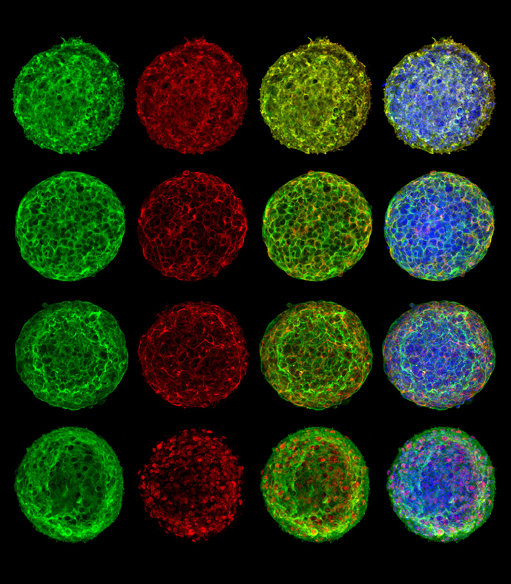
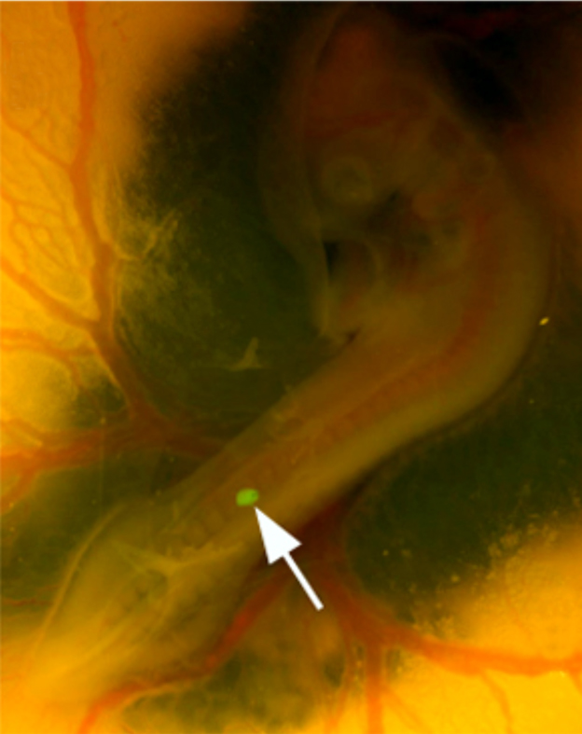
Figure 2. YFP-expressing neurosphere (arrow) as described in Fig.1 transplanted into the developing neural tube (primitive spinal cord) of a chick embryo. Subsequently, the YFP+ cells will be assessed for survival, migration, proliferation, differentiation and integration within the recipient spinal cord.
Figure 1. Enteric neurospheres, generated from Wnt-1Cre;R26YFP mouse gut. Wnt-1 positive neural crest cells express YFP (green). The neurospheres are stained with dapi (blue) and immuno-labelled with (from top to bottom in red) p75, TuJ1, GFAP, and Sox10. These immunomarkers demonstrate that enteric neurospheres contain neural crest-derived cells, neurons, glia and ENS stem cells.

