Project Resume

Title: Morphogenesis of the Molar Tooth Cusps and Sulci
Description: The generation of the biting surface of the molar tooth is largely established by the peaks (cusps) and valleys (sulci) of the underlying dental epithelium. Most theories of how these are generated have focused on cell proliferation, which is arrested in the prospective cusps, and the idea that the epithelial topography arises from buckling to accommodate increasing surface area within the confining dental capsule. This project first tested that hypothesis in mice and found that inhibition of proliferation did not prevent cusp or sulcus formation, refuting the conventional wisdom. Instead, cell shape changes, myosin- and focal adhesion kinase-inhibition experiments, and epithelium-specific myosin conditional genetic knockouts all pointed towards generation of bending forces within the epithelium, with some potential roles for immediately sub-adjacent mesenchyme. Preliminary laser-capture microdissection RNAseq experiments suggested potential molecular components of the cusp and sulcus generating apparatus.

First image shows frontal section of E15.5 molar tooth. Blue is DAPI (nuclei), red is mTomato-FP (cell membranes), green is phalloidin (filamentous actin enriched in condensing mesenchyme). Second image is frontal section of E16.0 molar showing sharper sulcus and two cusps. Red is GFP (epithelium-specific keratin-14-Cre driver), magenta is phalloidin.
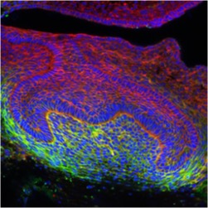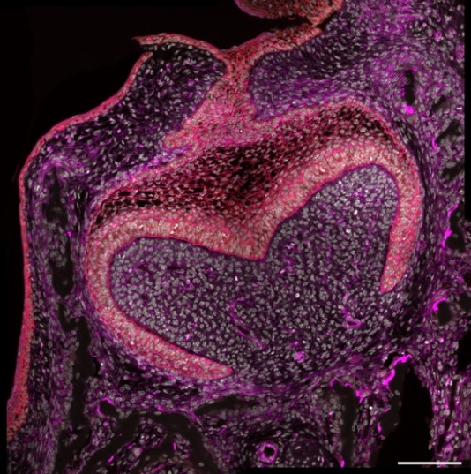

Project resume Green Piper – uploaded 170124

