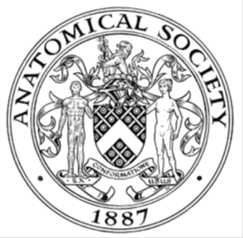
_______________________________________________________________________________________
AWARDEE REPORT FORM
_______________________________________________________________________________________

NAME |  | Katherine Geoghegan
UNIVERSITY |  | University of Southampton
NAME OF AWARD |  | Barclay Smith
PURPOSE OF AWARD conference/event attended/organised (full name) with city and dates.
International Federation of the Association of Anatomists, London 9th-11th August 2019

REPORT: What were your anticipated benefits?
I attended the IFAA in order to develop my academic interest especially in the fields of neuroanatomy and medical education. It was also an opportunity for me to present 2 posters containing data collected by a research group from the University of Southampton which I am a member of.
COMMENTS: Describe your experience at the conference
I had a fantastic time at IFAA 2019 exploring different aspects of primarily anatomy education but also up and coming research into more specific fields of anatomy. It was a fascinating opportunity to see the diversity within medical education across countries where philosophies and budgets differ. In attending the ‘Anatomical Sciences Education Symposia’ I was introduced to new ideas in the fields of medical education using a range of budgets and could see how the development of augmented and virtual reality will transform the way in which anatomy is taught. It was also a privilege to support my own research team in their presentations and posters across the weekend. On the Saturday of the event I had the opportunity to present 2 posters detailing research done into the perceived value of academic competition, both in the development of their anatomical knowledge and career development. This was an amazing opportunity to present my data to different anatomists from across the world and also introduce the idea of student-lecturer partnerships which is an area I am very passionate about. Many talks were fascinating including the transgender plenary and the weekend was a brilliant opportunity to meet many people who had experience of unique and interesting careers.

REPORT: In relation to skills, what were the most important things you gained? (does not apply to equipment grant. For public engagement/outreach awards what did your audience gain and how did you evaluate success?
This conference developed my academic poster presentation skills. This enabled me to develop my research to a point where it was presentation worthy and valuable to those attending the conference. It was also a fantastic networking opportunity and gave me the ability to interact with other anatomists and students from across the world. Aside from this, attendance at the conference gave me an insight into further developments in anatomical education and different methods which I would not have encountered without attending the conference.

REPORT: How do you think you will put this learning experience into practice in the future? For public engagement/outreach awards how with the materials/knowledge generated by this activity be used in the future?
The innovative ideas presented at this conference will definitely shape the way I teach and the direction of future research. In being exposed to the advanced technology now available and the way that student partnership has been used to develop this I am excited at the potential opportunities to do this within our faculty. Through meeting a number of previous medical students who are advanced in their academic careers I have become aware of interesting career options that I was not aware of previously.
Data Protection/GDPR: I consent to the data included in this submission being collected, processed and stored by the Anatomical Society.
YES
Graphical Images: If you include graphical images you must obtain consent from people appearing in any photos and confirm that you have consent. A consent statement from you must accompany each report if relevant. A short narrative should accompany the image.
YES

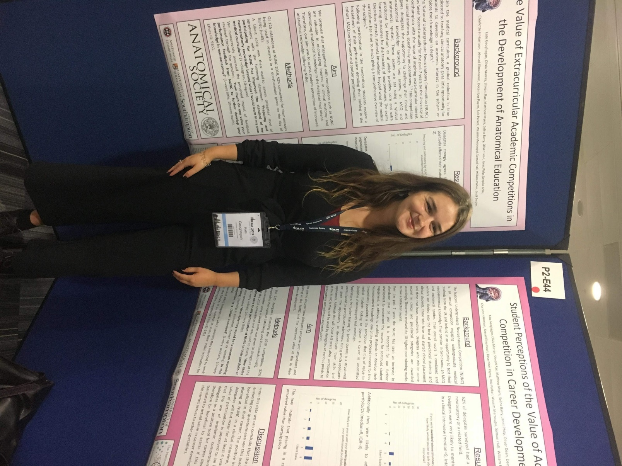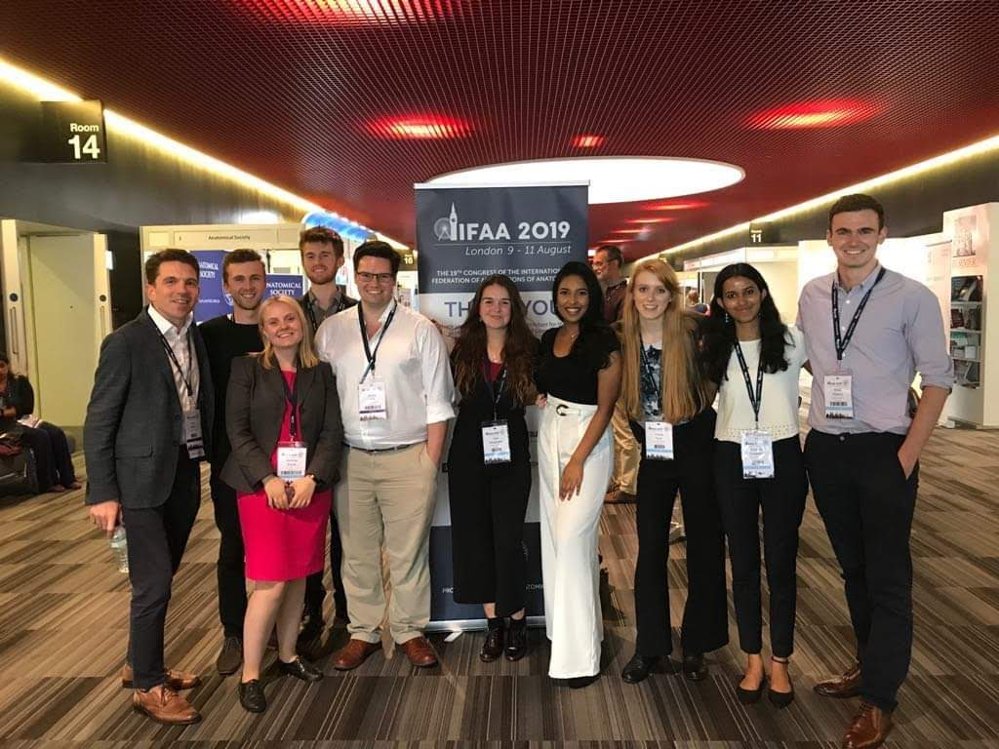

Copyright: If you submit images you must either own the copyright to the image or have gained the explicit permission of the copyright holder for the image to be submitted as part of the report for upload to the Society’s website, Newsletter, social media and so forth. A copyright statement must accompany each report if relevant.
YES

SIGNATURE | K Geoghegan |  | DATE | 12/08/2019
If submitted electronically, a type-written name is acceptable in place of a hand-written signature

File: AS-Award-Report-Form-BLANKCO-SEAL-date110216-Amended AT-070818

File: Report BS1819R5 Final all changes accepted KG

