Title: Elucidating the function of the dopaminergic midbrain-claustrum projection in the healthy brain and in Parkinson’s disease

First Supervisor: Dr Mariah Lelos, Cardiff University, U.K.

Second Supervisor: Prof Anne Rosser, Cardiff University, U.K.

Overview:

Very little is known about the nature and function of the midbrain-claustral projection in the brain. The claustrum itself remains fairly enigmatic, but it harbours two unique features that suggest its importance in the brain. Firstly, it receives innervation from almost every region of the cortex and it sends projections back to every region of the cortex, but only receives input from select subcortical regions. Secondly, it is present in the brains of all mammals, most reptiles and avian species. The unique projection pattern of the claustrum has spawned theories that the claustrum is involved in cognitive processes ranging from salience detection, to multisensory integration, to cortical network instantiation underlying cognitive control. However, it remains unknown how dopamine transmission mediates the activity of the claustrum, nor how loss of dopamine affects the integrity of this region.

Although people with Parkinson’s disease are diagnosed on the basis of motor dysfunction, non-motor (including cognitive and neuropsychiatric) symptoms manifest early in the course of the disease and, as the disease progresses, up to 80% are diagnosed with dementia. A recent study using MRI in people with Parkinson’s disease has suggested that aberrant claustral connectivity may be associated with specific aspects of cognitive dysfunction. Reduced dopamine and noradrenaline (but not serotonin) have been reported in the claustrum of people with Parkinson’s, and consistent with this, we have observed significantly reduced dopamine innervation to the claustrum in our rat models of Parkinson’s disease, even in pre-symptomatic models with minimal loss of midbrain dopamine neurons (Figure 1).

The unique projection patterns of the claustrum, together with the evidence that claustral dopamine innervation may be disrupted in Parkinson’s disease, suggests that this midbrain-claustral projection may play an important role in supporting cognitive function in the healthy and Parkinsonian brain. However, surprisingly, this has never been directly explored. Thus, the aim of this project is to elucidate the nature and function of the midbrain-claustral project using both rodent models and human brain tissues.
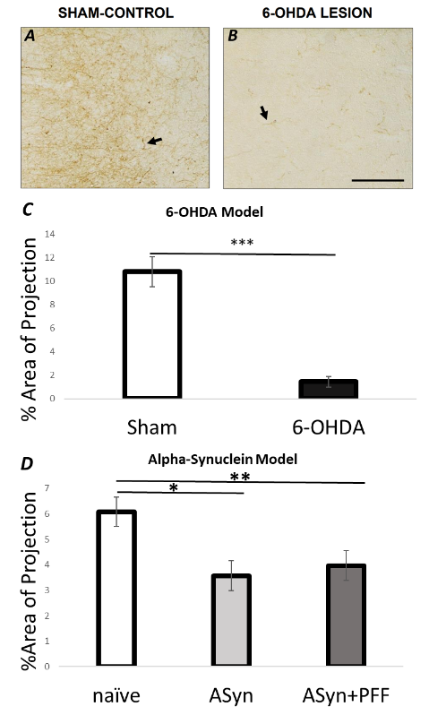
Figure 1: Reduced innervation of the claustrum in 3 rodent models of Parkinson’s disease. (A-B) Representative tyrosine hydroxylase (TH) immunostaining of the claustrum in sham and 6-OHDA lesioned rats. (C) Percentage of area covered by TH+ fibres in sham and 6-OHDA rats. (D) Percentage of area covered by TH+ fibres in naïve rats, Parkinsonian rats with AAV overexpression of alpha-synuclein in the midbrain (ASyn), and Parkinsonian rats with AAV overexpression of alpha-synuclein, plus preformed fibrils (Asyn+PFF).

The overarching aim of this project is to understand the role of dopaminergic transmission on claustrum function and its relationship to cognitive decline in Parkinson’s disease.

Objective 1: To characterise the subtype of midbrain dopamine neuron projecting to the claustrum in the rat brain.

Objective 2: To elucidate the function of the midbrain-claustral dopamine projection in rats.

Objective 3: To determine whether the midbrain-claustral dopamine projection is perturbed in the brains of people with Parkinson’s disease.

