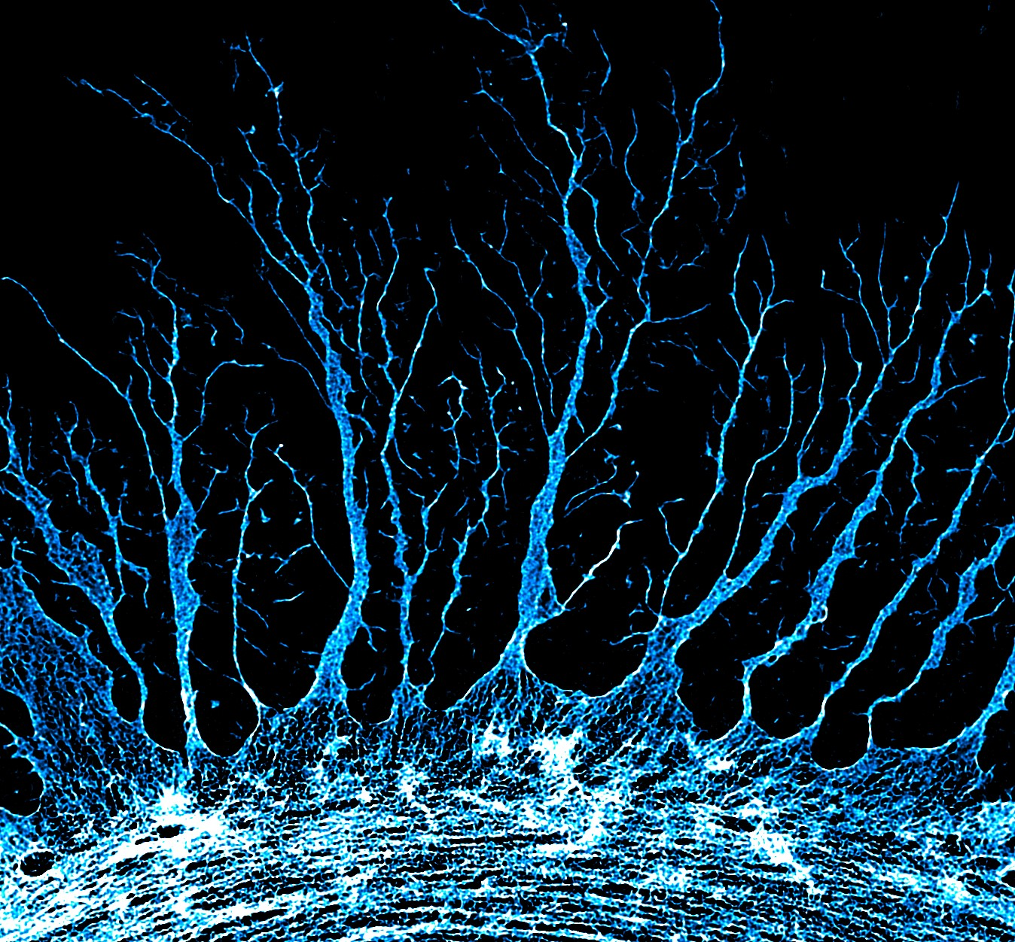

File: Super Resolution Astrocyte – Website Upload 190723

