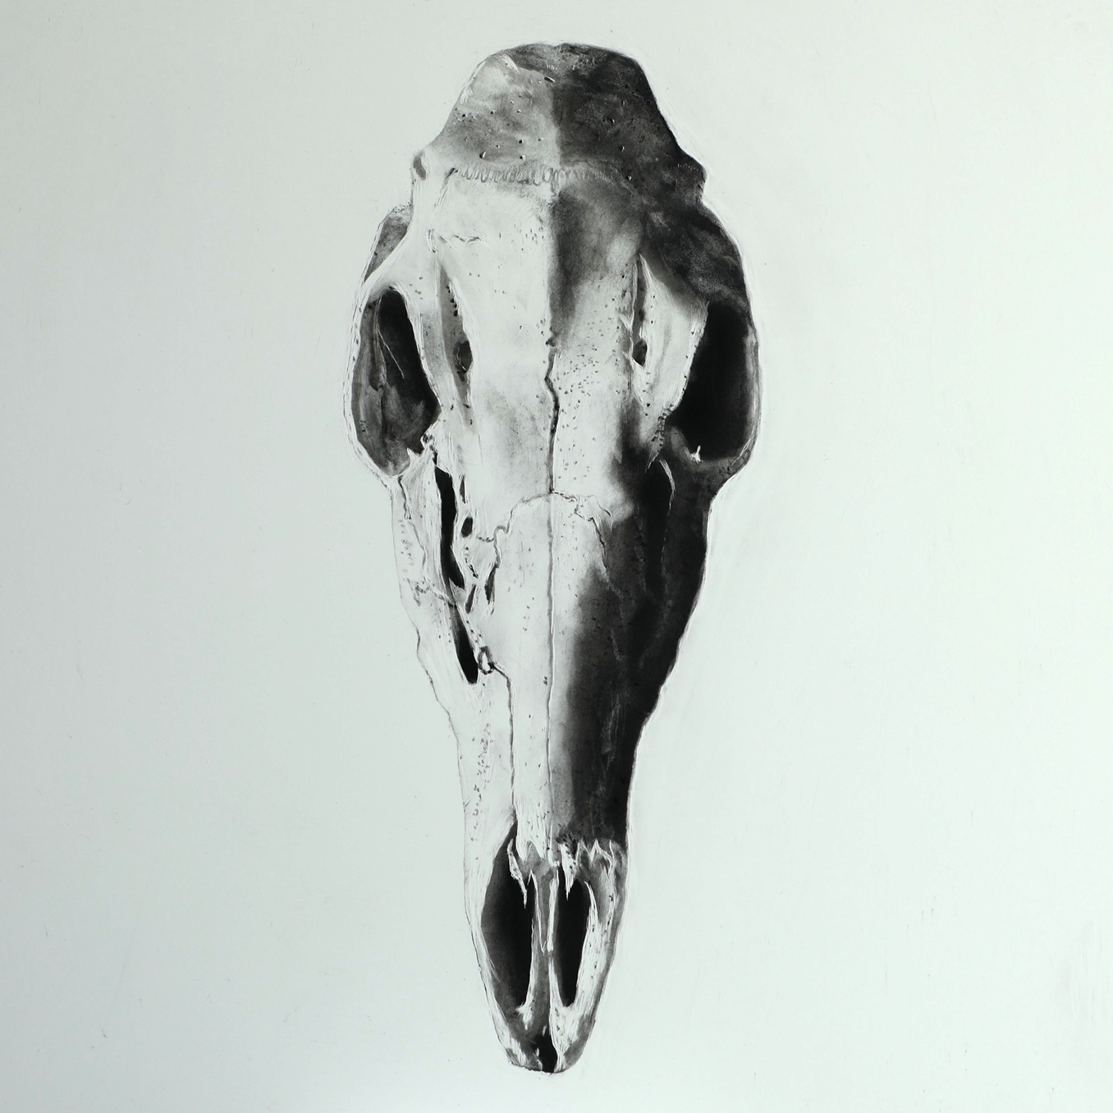

File: Whitetail Deer Skull – Upload 190723

